CVRP Greedy vs Clarke Wright vs Local Search Synthetic

CSC-2400 Design of Algorithms
By: Bryson Bargas and Noah Boggess

Tennessee Technological University

April 27th, 2026
GitHub: https://github.com/BryceMani4c/CVRP_Greedy_vs_ClarkeWright_vs_LocalSearch_Synthetic
Table of Contents
CVRP Greedy vs Clarke Wright vs Local Search Synthetic 1
1.Overview of Problem and Methods 3
2. Research Questions 4
3. Description of Experiments 5
Implementation 5
Dataset 5
Performance Metrics 5
Baseline Method 6
4. Results 7
5. Analysis and Interpretation 9
6. Sources 10
7. Work Distribution 11
8. Limitations and Future Work 12

1.Overview of Problem and Methods
The Vehicle Routing Problem (VRP) is a well-known optimization problem in which a fleet of vehicles must deliver goods to a set of customers while minimizing total travel distance and respecting constraints such as vehicle capacity.
VRP is computationally difficult and belongs to the class of NP-hard problems, meaning exact solutions become infeasible for large inputs. As a result, heuristic and approximation algorithms are commonly used.
In this project, we implemented and analyzed three approaches:
- Greedy Nearest Neighbor – constructs routes by repeatedly visiting the closest feasible customer
- Clarke-Wright Savings Algorithm – builds routes by merging customers based on distance savings
- Local Search (2-opt) – improves existing routes by iteratively reducing path length
Greedy serves as a baseline method, while Clarke-Wright and Local Search aim to improve solution quality.

2. Research Questions
The following research questions were defined prior to conducting experiments:
- How does solution quality (total distance) compare between Greedy and Clarke-Wright?
- Does Local Search significantly improve the Greedy solution?
- How do the algorithms compare in terms of runtime efficiency?
- What trade-offs exist between solution quality and computational cost?
Expectation:
We expect Clarke-Wright to produce better routes than Greedy, and Local Search to further improve solutions at the cost of increased runtime.

Description of Experiments

Implementation
All algorithms were implemented in C++ using modular files:
- greedy.cpp
- clarke_wright.cpp
- local_search.cpp
- run_experiments.cpp

Dataset
We used a standard Solomon benchmark dataset:
- Dataset: C101.txt and other data sets.
- Number of customers: C101 uses 100 customers.
- Depot location: included in dataset
- Customer demands and coordinates provided

Performance Metrics
We evaluated each algorithm using:
- Total route distance
- Number of vehicles used
- Execution time (seconds)

Baseline Method
A brute-force solution was not implemented due to exponential complexity. Instead, the Greedy algorithm serves as a baseline for comparison.
System Specifications: Based upon Noah Boggess’s personal laptop.
- CPU: 11th Gen Intel Core i9-11900H @ 2.50 GHz (8 cores, 16 threads)
- RAM: 32 GB
- OS: Windows 11
Experiment Procedure
- Load dataset
- Run Greedy algorithm
- Run Clarke-Wright algorithm
- Apply Local Search to Greedy solution
- Measure runtime and total distance
- Compare results

============================================================
SUMMARY COMPARISON
============================================================
Algorithm Distance Vehicles Time (s)
------------------------------------------------------------
Greedy Nearest Neighbor 1311.50 10 0.001298
Clarke-Wright Savings 833.51 10 0.015751
Local Search (2-opt) 1239.44 10 0.007533
------------------------------------------------------------
- Clarke-Wright vs Greedy: 36.45% improvement
- Local Search vs Greedy: 5.49% improvement

Results

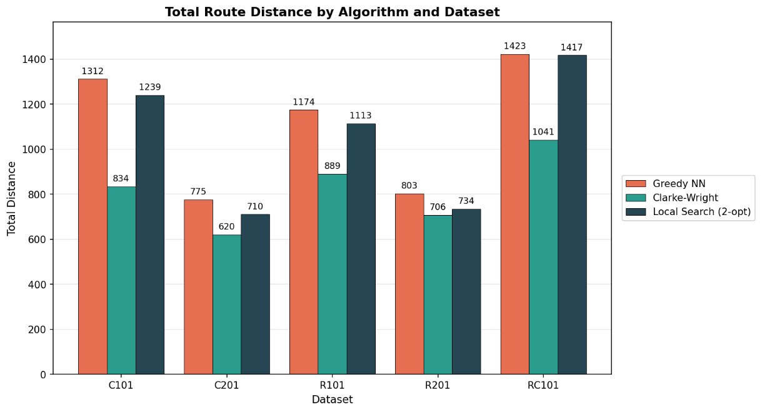
Figure 1 Total Route Distance by Algorithm and Dataset
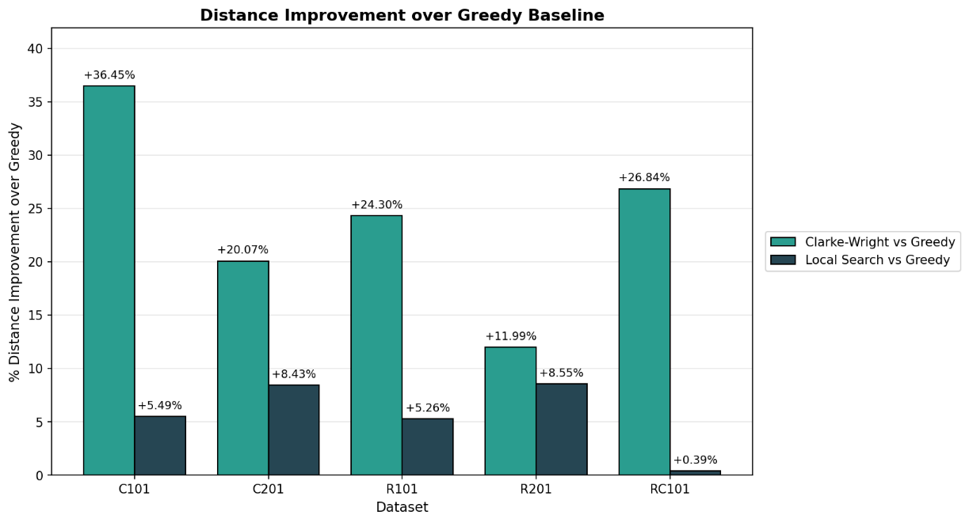
Figure 2 Distance Improvement over Greedy Baseline
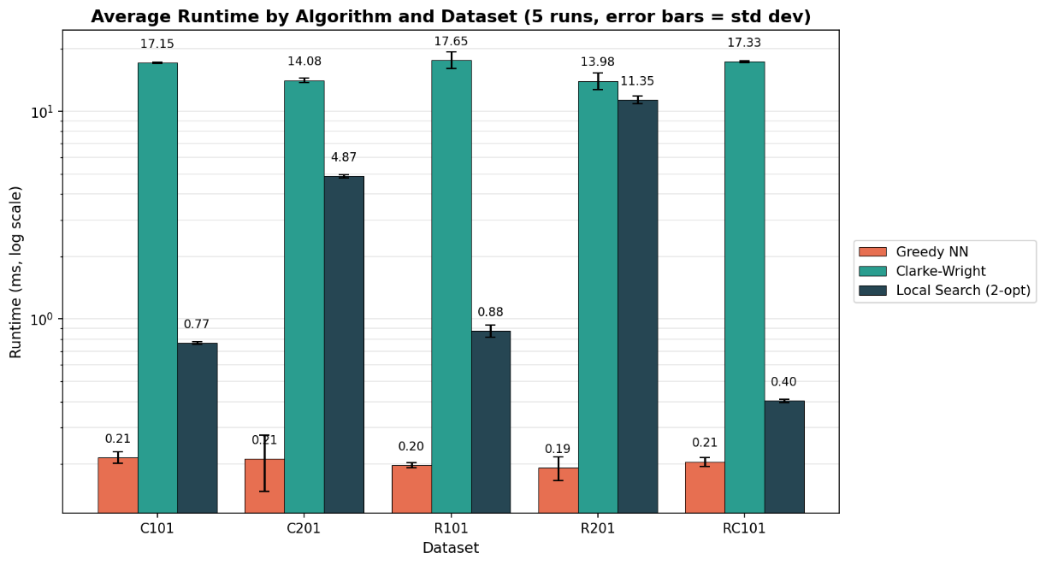
Figure 3 Average Runtime by Algorithm and Dataset

Analysis and Interpretation
The results demonstrate clear differences in performance between the algorithms across all five Solomon datasets.
The Greedy Nearest Neighbor algorithm produced the fastest runtime by a significant margin as shown in Figure 3, averaging between 0.19 and 0.22 ms on every dataset. The biggest tradeoff is its total route distance, which was the highest of the three algorithms on every dataset as shown in Figure 1, ranging from 775.49 on C201 up to 1422.60 on RC101.
The Clarke-Wright Savings algorithm achieved the best overall performance on every dataset as shown in Figure 1, with improvements over Greedy ranging from 11.99% on R201 up to 36.45% on C101 as shown in Figure 2. Its runtime averaged between 13.98 and 17.65 ms across the five datasets (Figure 3), but the substantial improvement in solution quality demonstrates the effectiveness of the savings-based route merging strategy.
The Local Search (2-opt) algorithm improved the Greedy solution on every dataset, but the improvement varied widely as shown in Figure 2 — from just 0.39% on RC101 to 8.55% on R201. While these improvements are smaller than those of Clarke-Wright, it shows that iterative optimization can refine an existing solution. Local Search's runtime is also dataset-dependent, ranging from 0.40 ms on RC101 up to 11.35 ms on R201 (Figure 3), since 2-opt's runtime depends on how many passes it needs before converging on each particular Greedy starting solution.
All three algorithms used the same number of vehicles within each dataset (10 for C101, 3 for C201, 8 for R101, 2 for R201, and 9 for RC101), indicating that improvements were achieved through route optimization rather than reducing fleet size.

Sources
- Solomon benchmark dataset (Marius M. Solomon, 1987), the Clarke-Wright 1964 paper
- Claude AI
  - Generating Charts
  - Assisting in writing code to input data from Solomon Benchmark Data Set
  - Read-Me for Github page

Work Distribution
This table is very rough as most of the work was done together, excluding the final report and power point presentation, whether it was writing the final checks together or programing on shared files.
Stages of Project | Bryson Bargas | Noah Boggess
Brainstorming | 50% | 50%
Coding | 50% | 50%
Experiment Design | 50% | 50%
Visualization/Results | 70% | 30%
Communication | 50% | 50%
Submission | 50% | 50%
Report Writing | 50% | 50%
Presentation | 10% | 90%

Limitations and Future Work

Several limitations were present in this experiment.
- No optimal (exact) solution was computed for comparison
- Local Search may become trapped in local minima, preventing further improvements
- Clarke-Wright relies on heuristic savings and may not always produce optimal merges
If this project were extended, we would:
- Compare results across different VRP instances (e.g., R and RC datasets)
- Analyze scalability by increasing the number of customers

